**SQL PROGRAMS**

1. Write a program to display ‘Hello’.

**PROGRAM&OUTPUT:**

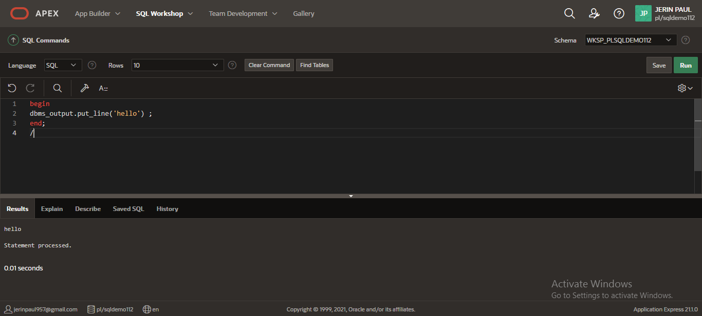

2. Write a program to display sum of 2 numbers.

**PROGRAM&OUTPUT:**

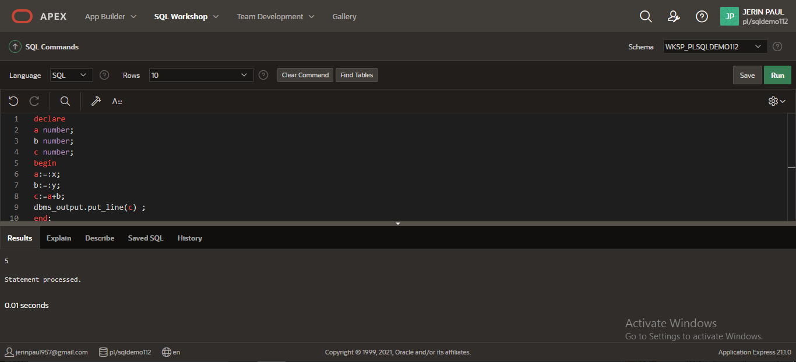

3. Write a program to display 1 to 5.

**PROGRAM & OUTPUT:**

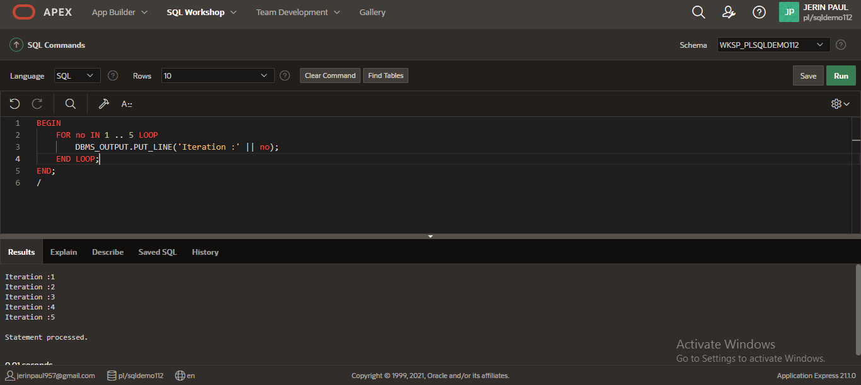

4. Write a program to display sum of 10 numbers.

**PROGRAM AND OUTPUT:**

